**Assignment 13**

The following are to be written up and turned in separately from the rest of the homework.

1. Using the DFS Template Method Pattern algorithm given in the lecture notes, override the appropriate methods so this algorithm computes the connected components of a graph ***G***. Your method should return a sequence of vertices, 1 representative from each connected component.

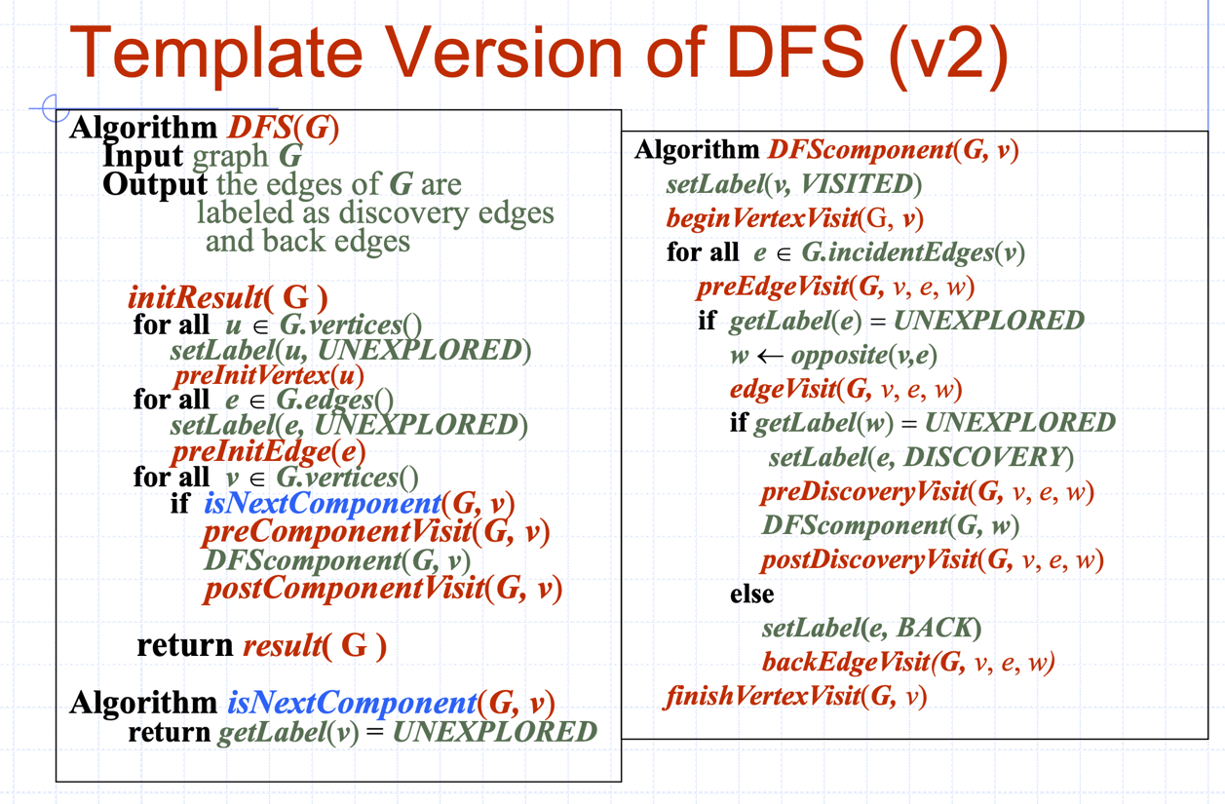

Answer:

Algorithm **initResult**(G)

S🡨newEmptySequence // S from subclass field

Algorithm **result**(G)

return S

Algorithm **preComponentVisit**(G,v)

S.insertLast(v)

Algorithm **representative**(G)

return DFS(G)

2. a. Modify the breadth-first search algorithm so it can be used as a Template Method Pattern.

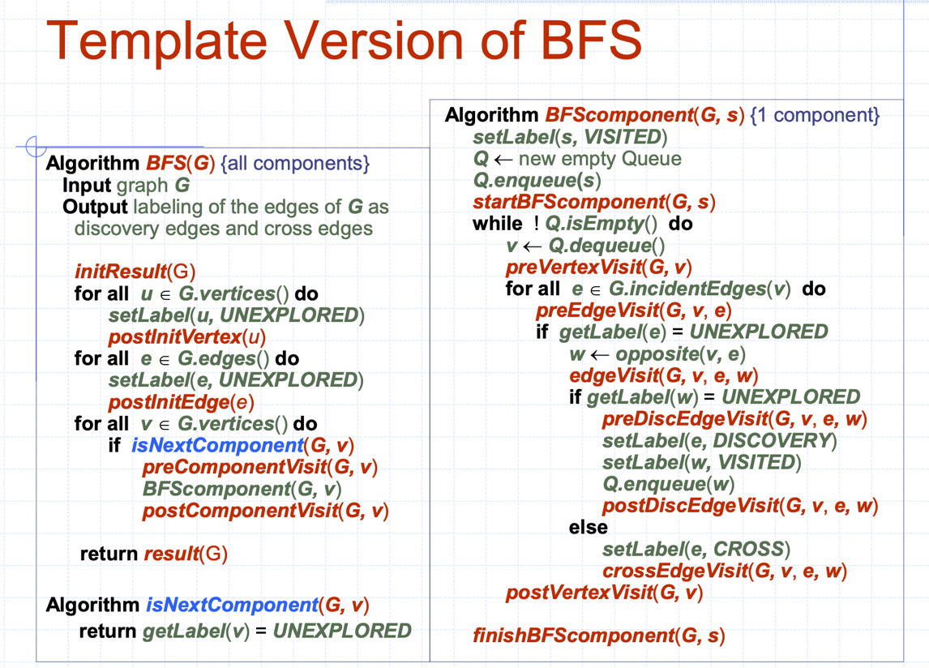

b. Write a pseudo code function **findPath**(G, u, v) that uses your Template Method from (a) to find a path in ***G*** between vertices u and v with the **minimum** number of edges, or report that no such path exists. Hint: Override the appropriate methods so that given two vertices u and v of ***G***, your call to **BFS** finds and returns a Sequence containing the path between u and v.

Answer:

Algorithm **initResult**(G)

S🡨newEmptySequence // S from subclass field

path🡨 ∅ //path from subclass field

Algorithm **result**(G)

return path

Algorithm **preComponentVisit**(G,v)

S.insertLast(v)

start🡨v // start from subclass field.

Algorithm **preDiscEdgeVisit**(G,v,e,w)

S.insertLast(w)

if w = desk then //desk from subclass field

path 🡨 S.elements()

Algorithm **representative**(G)

return BFS(G)

c. Write a pseudo code function **findCycle**(G) that uses your Template Method from (a) to find a simple cycle in a graph ***G*** (any cycle, not all cycles). That is, override the appropriate methods so your solution finds a cycle in G. You are to return a Sequence containing the cycle.

Answer:

Algorithm **initResult**(G)

S🡨newEmptySequence // S from subclass field

path🡨 ∅ //path from subclass field

Algorithm **result**(G)

return path

Algorithm **preComponentVisit**(G,v)

S.insertLast(v)

Algorithm **crossEdgeVisit**(G,v,e,w)

S.insertLast(w)

path 🡨 S.elements()

Algorithm **findCycle**(G)

return BFS(G)

d. Can the template version of DFS be used to find the path between two vertices with the minimum number of edges? Briefly explain why or why not.

Answer: Yes, it can. For each edge is an incident of vertex u, we **findPath**(G, u, v) and then return the path containing a minimum number of edges.

4. Based on either the DFS or the BFS template method algorithms, write the overriding methods so that all nodes in each connected component of a graph G are labeled with a sequence number, i.e., each vertex in a component would be labeled with the same number. For example, each node in the first connected component would be labeled with a 0, each node in the second connected component would be labeled with a 1, etc.

Answer:

Algorithm **initResult**(G)

index 🡨 0 // S from subclass field

Algorithm **preComponentVisit**(G,v)

v.setIndex(index)

Algorithm **preDiscEdgeVisit**(G,v,e,w)

w.setIndex(v.getIndex())